Report Title: A Review of FPGAs and PLCs Unit Code - EMT 3104: Mechatronic Systems Programming I Student Number: E022-01-0794/2021 Student Name: Njeri Newton Kariuki Submission Data: 27th May 2021

Table of Contents
Introduction 3
Field Programmable Gate Arrays (FPGA) 3
Architecture of FPGAs 3
FPGA History 4
Programming of FPGAs 4
Applications of FPGAs 4
Advantages of FPGAs 4
Programmable Logic Controller 5
PLC Architecture 5
History of PLCs 5
Programming of PLCs 6
How PLCs differs from an ordinary computer 6
Application of PLCs 6
Advantages of PLC over earlier automation system: 7
Conclusion 7
References 7

Introduction
In industries or in any other place some tasks need to be automated. Automation of the tasks comes in as a the task may require high precisions, the tasks may be repetitive and “simple” or due to its nature it may not be suitable for it to be carried out by a human being. As a result FPGAs and PLCs come in to the rescue. PLCs are mostly used for industrial applications since they are designed to withstand conditions such as those experienced in industrial environment. On the other hand FPGAs are mostly applied in areas such as equipment for video and imaging, circuitry for computer, auto, aerospace etc. This is just to mention a few of their application; therefore, it is of much importance to have basic understanding of FPGAs and PLCs.

Field Programmable Gate Arrays (FPGA)
An FPGA is an integrated circuit designed to be configured by a customer or a designer after manufacturing. It can also be define as an integrated circuit that consists of internal hardware blocks with user-programmable interconnects to customize operation for a specific application.
FPGAs come in a variety of sizes ranging from small to very large to acccommodate the requirements of the particular project.

Architecture of FPGAs
A basic FPGA architecture consist of thousands of fundamental elements called configurable logic blocs (CLBs) surrounded by a system of programmable interconnects called a fabric that routes signals between the CLBs. In addition it has I/O blocks which interface the FPGA and the external devices.
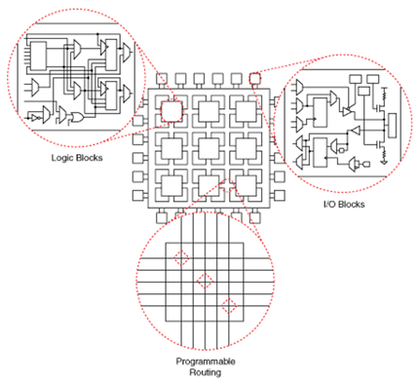
Figure 1: Basic CLB architecture
FPGAs have large numbers of logic gates and RAM blocks to implement complex digital computations and their designs employ fast I/O rate and bidirectional data buses. Another design in design of FPGAs is the Floor Planning design, which enables resource allocation within FPGAs.
Other FPGAs have analogue features in addition to the digital functions. These analogue features include programmable slew rate, quartz-crystal oscillators, on-chip resistance-capacitance oscillators, and phase locked loops with embedded voltage-controlled oscillators. Another group of FPGAs is the mixed signal FPGAs in which there are integrated peripherals analog-to-digital converters (ADCs) and digital-to-converters (DACs) with analog signals conditioning blocks allowing them to operate as a system-on-a-chip (SoC).

FPGA History
This industry sprouted from Programmable read-only memory (PROM) and Programmable Logic Devices (PLDs). The first FPGA – the EP300 - was delivered in 1984 by Altera. It featured a quartz window in the package that allowed users to shine an ultra-violet lamp on the die to erase the EPROM cells that held the device configuration. The first commercially available FPGA was invented by Xilinx co-founders Ross Freeman and Bernard Vonderschmitt in 1985 –the XC2064. This FPGA had programmable gates and programmable interconnects between gates, making the beginning of a new era in the industry.

Programming of FPGAs
FPGAs circuits are created using Hardware Description Languages (HDLs). For large complex circuits the behaviour wanted in the circuit is described and the tools figures out how to implement it. .HDLs, most commonly used are VHDL, Verilog and LabVIEW FPGA. HDLs describe the hardware and the end product of the designs or instructions created using them are physical circuits though the process is complicated.
HDLs differ from the normal programming languages in that they are able to accommodate parameters including propagation parameters and also the signal strengths. The two parameters are of key importance in programming of the FPGAs.

Applications of FPGAs
- DSP functions in mobile market e.g. voice recognition
- Data centre hardware acceleration
- Artificial Intelligence
- Automotive advanced driver assistance systems
- Image Processing
- Enterprise networking
- Aerospace and defence
- Cyber Security
- Industrial Motor Control

Advantages of FPGAs
- Long term availability
- Updating and adaptation at the customer
- They are fast and efficient
- Acceleration of software
- Ideal for applications in time critical systems
- Parallel processing of data in FPGAs offers solution for processing of large amount of data which can no longer be processed in a timely manner using the sequentially operating systems

Programmable Logic Controller
A PLC is an industrial digital computer that has been ruggedized and adapted for the control of manufacturing processes or any other activity that requires high reliability, ease of programming, and process fault diagnosis.

PLC Architecture
A PLC consists of a CPU, power supply unit, memory unit, input and output interface and a communication interface each of these constituents performing a specific task(s). The PLC also requires a programming device used for developing and later downloading the created program into the memory of the controller. In addition to these constituents some modern PLCs have an real-time operating system.
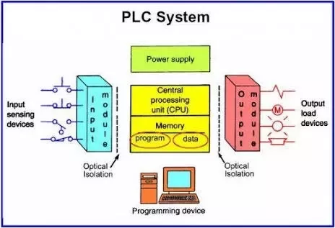
Figure 2: PLC System
Considering the mechanical design, PLCs are of two types’ single box and modular PLC. A single box is that which fits all units and interfaces into a compact casing, although, additional expansion modules for input and output are available. Modular PLC on the other hand has a chassis (rack) that provides space for modules with different functions which can be customized for a particular application.

History of PLCs
The first PLC, the Modicon 084, was invented by Dick Morley of General Motors in 1968. They were first developed in the automobile manufacturing industry to provide flexible, rugged programmable control to replace hard-wired relay logic systems.
As of today, trends such as shrinking of size of circuit boards, processors and other electronic components, use of portable memory devices and decrease in sizes and cost of solid state memory are being witnessed. The result of these trends is change in design of PLCs and overall increase of their efficiency.

Programming of PLCs
The CPU of a PLC executes two programmes, the operating system and the user uploaded programme. The operating system organizes all the functions, operations and sequences of the CPU that are not associated with a control task. The user programme is a combination of various functions which are required to process an automated task. It consists of a set of instructions either in textual or graphical form represented for the logic to be implemented for specific industrial real-time applications. As its name suggests, it is created by the user and is uploaded to the CPU of the PLC.
Textual language
- Instructions List (IL)
- Structured Text (ST)
Graphical language
- Ladder Diagrams (LD)
- Function Block Diagram (FBD)
- Sequential Function Chart (SFC)
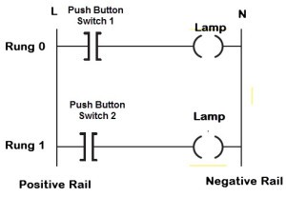
Figure 3: Ladder Logic PLC Programming an example of Graphical Language

How PLCs differs from an ordinary computer
- A PLC is designed to perform a single set or sequence of tasks with greater performance and reliability. This in contrast to the regular PCs and smart phones designed to perform multiple tasks simultaneously within the windows framework.
- A PLC has additional features such protection from open area conditions such as heat, dust etc.
- PLCs are low cost when compared to other microcontroller systems since while working with PLCs for various application only the software component is changed to suit a particular application. Working with microcontrollers one has to change the hardware components for different applications.

Application of PLCs
- PLCs are used to operate and monitor safety control systems in escalators and lifts.
- PLCs are used in coal-fired boiler fan change-over systems in hospitals, silo feed, corrugation machine control system etc.
- PLC uses for the Smart Grid System to Monitor and Detect fault conditions.
- PLCs are used in Smart Traffic Control Signal System.
- Remote Monitoring Application like Air compressor (AC), Fan.
- ON/OFF Switching Application like Light, Motor, and More daily life applications of PLC.
- Industrial Crane Control System for Operation of Overhead Traveling Crane.
- Glass Industries for glass production and recording data.
- Paper Industries for the production of Pages, Books or Newspapers, etc.
- Cement Industries for manufacturing or mixing the right quality and quantities of raw materials, and accuracy of data regarding.

Advantages of PLC over earlier automation system:
- It tolerated the industrial environment than computers
- It was more reliable
- More compact
- Required less maintenance than relay system
- More user friendly than computers using general purpose programming language
- Low power consumption
- Analog signal handling and control loop programming

Conclusion
The research outlines the architecture, history, pros and cons, and applications of FPGAs and PLCs. From their applications it is clear that FPGAs and PLCs are of much use in our day to day life, from industries to the toys used by children. It is also clear that both are technologies of the twentieth century and at the moment both are experiencing trends that are increasing their performance and reducing their costs of production and meintanance.

References
- https://www.mobileautomation.com.au
- https://dipslab.com/plc-applications/
- https://www.watelectronics.com/how-to-program-the-programmable-logic-controllers/#:~:text=The%20PLC%20programming%20is%20an,for%20specific%20industrial%20realtime%20applications.
- https://www.c3controls.com/white-paper/history-of-programmable-logic-controllers/

